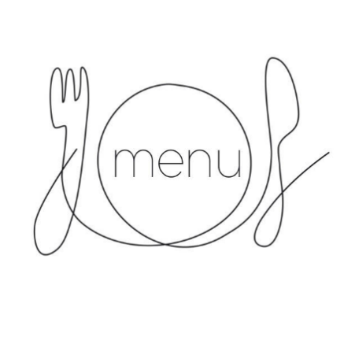**Lunch Menu - Week 1**

**Monday**

Chicken Curry/Thai Red Vegan Curry (V)

Basmati Rice

Broccoli

Madeira Sponge

**Tuesday**

Sausages/Vegetarian Sausages (V)

Mashed Potatoes/Sauté Potatoes

Spaghetti Hoops/Green Beans

Angel Delight (Nursery)

**Wednesday**

Roast Chicken in gravy/Vegan Roast (V)

Golden Roasted Potatoes, Yorkshire Pudding

Vegetable Medley

Chocolate Chip Sponge and Custard

**Thursday**

Pasta Bolognaise/Vegetarian Bolognaise

Garlic Bread

Sauté Potatoes

Sweetcorn/Peas

Vanilla Iced Sponge

**Friday**

Fish Fingers/Vegetarian Option (V)

Chips

Baked Beans/Peas

Fresh Fruit/Ice Cream Sponge Roll

*Menus subject to availability*

*Other allergies catered for individually*

**Lunch Menu - Week 2**

**Monday**

Chicken and Pasta in tomato sauce/Penne Pasta in tomato sauce (Nursery) (V)

Chicken Goujons/Macaroni Cheese (V) (School)

Sauté Potatoes

Broccoli

Chocolate Sponge and custard

**Tuesday**

Lasagne/Cheese and Onion Pie (V)

Chips

Carrots

Apple Crumble and Custard (Nursery)

**Wednesday**

Chicken and Vegetable Pie (Nursery)

Mash Potato and peas (Nursery)

Roast Chicken in Gravy/Vegan Roast (V) (School)

Golden Roasted Potatoes, Yorkshire Pudding

Vegetable Medley (School)

Chocolate Chip Sponge and Custard

**Thursday**

Meatballs and Mashed Potatoes (Nursery)

Margherita Pizza (V) (School)

Sauté Potatoes

Sweetcorn and Peas

Fruit in Jelly

**Friday**

Fish Fingers/Vegetarian Option (V) (Nursery)

Fish Goujons/Vegetarian Option (School)

Chips

Baked Beans/Peas

Fresh Fruit/Ice Cream Sponge Roll

*Menus subject to availability*

*Other allergies catered for individually*



**Lunch Menu - Week 3**

**Monday**

Chicken and Vegetable Pie/Cheese and Onion Pie (V)

Croquette Potatoes

Sweetcorn

Orange and Lemon Sponge Pudding (GF) and Custard

**Tuesday**

Sausage Casserole/Vegetarian Sausages (V)

Hash Browns

Broccoli

G/F Plain sponge and Custard

**Wednesday**

Roast Chicken in gravy/Vegan Roast (V)

Golden Roasted Potatoes, Yorkshire Pudding

Vegetable Medley

Chocolate Chip Sponge and Custard

**Thursday**

Meatballs

Mashed potatoes

Sliced Carrots

Lemon Sponge and Custard

**Friday**

Fish Fingers/Vegetarian Option (V)

Chips

Baked Beans/Peas

Ice Cream Sponge Roll

*Menus subject to availability*

*Other allergies catered for individually*

*Menus updated 8/01/2025*