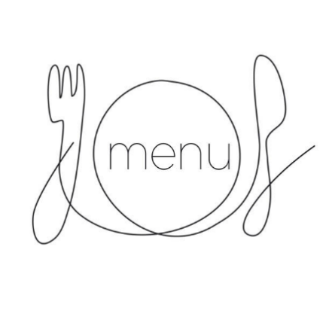**Lunch Menu - Week 1**

**Monday**

Chicken Curry/Thai Red Vegan Curry and naan bread (V)

Basmati Rice

Broccoli

Madeira Sponge

**Tuesday**

Sausages/Vegetarian Sausages (V)

Mashed Potatoes/Sauté Potatoes

Green Beans

Angel Delight

**Wednesday**

Roast Chicken in gravy/Vegan Roast (V)

Golden Roasted Potatoes, Yorkshire Pudding

Mixed Vegetables

Chocolate Chip Sponge and Custard

**Thursday**

Pasta Bolognaise/Lentil Bolognaise and pasta

Garlic Bread

Broccoli

Carrot tips

Vanilla Iced Sponge

**Friday**

Fish Fingers/Vegetarian Option (V)

Chips

Baked Beans/Peas

Ice Cream (Nursery) / Fruit Salad (School)

*Menus subject to availability*

*Other allergies catered for individually*

**Lunch Menu - Week 2**

**Monday**

Chicken and Pasta in tomato sauce/Penne Pasta in tomato sauce (Nursery) (V)

Chicken Goujons/Macaroni Cheese (V) (School)

Sauté Potatoes

Broccoli

Chocolate Sponge and custard

**Tuesday**

Lasagne/Tempeh, Spinach & Sweet Potato Hotpot (V)

Chips

Carrots

Pineapple Sponge and Custard / Yoghurt

**Wednesday**

Chicken and Vegetable Pie (Nursery)

Mash Potato and peas (Nursery)

Roast Chicken in Gravy/Vegan Roast (V) (School)

Golden Roasted Potatoes, Yorkshire Pudding

Mixed Vegetable (School)

Chocolate Chip Sponge and Custard

**Thursday**

Meatballs / Lentil bolognaise (V) and Mashed Potatoes (Nursery)

Margherita Pizza (V) (School)

Sauté Potatoes

Sweetcorn and Peas

Fruit in Jelly

**Friday**

Fish Fingers/Vegetarian Option (V) (Nursery)

Fish Goujons/Vegetarian Option (School)

Chips

Baked Beans/Peas

Fruit Salad

*Menus subject to availability*

*Other allergies catered for individually*



**Lunch Menu - Week 3**

**Monday**

Chicken and Vegetable Pie/Tomato & Chickpea Gratin (V)

Croquette Potatoes

Sweetcorn

Madeira Sponge (GF) and Custard

**Tuesday**

Cottage pie / Vegetarian Cottage pie (V)

Carrot tips

Broccoli

Hot Chocolate Brownie and custard

**Wednesday**

Roast Chicken in gravy/Vegan Roast (V)

Golden Roasted Potatoes, Yorkshire Pudding

Mixed Vegetable

Chocolate Chip Sponge and Custard

**Thursday**

Meatballs + Lentil Bolognaise (V)

Mashed potatoes

Sliced Carrots

Angel Delight

**Friday**

Fish Goujons/Vegetarian Option (V)

Chips

Baked Beans/Peas

Fruit Salad

*Menus subject to availability*

*Other allergies catered for individually*

*Menus updated 11/02/2025*