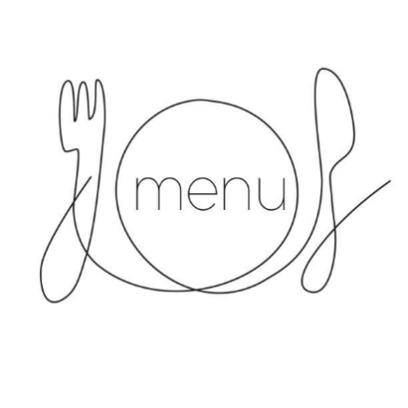
Lunch Menu - Week 1

Monday

Chicken Curry/Thai Red Vegan Curry and naan bread (V)
Wholegrain Rice
Broccoli
Madeira Sponge

Tuesday

Sausages/Vegetarian Sausages (V)
Mashed Potatoes
Green Beans
Angel Delight

Wednesday

Roast Chicken in gravy/Vegan Roast (V)
Golden Roasted Potatoes, Yorkshire Pudding
Mixed Vegetables
Chocolate Chip Sponge and Custard

Thursday

Pasta Bolognaise/Lentil Bolognaise and pasta
Garlic Bread
Broccoli
Carrot tips
Fruit and yogurt

Friday

Salmon Fingers/Vegetarian Option (V)
Chips
Baked Beans/Peas
Ice Cream (Nursery) / Peaches in juice (School)

Menus subject to availability
Other allergies catered for individually
Lunch Menu - Week 2

Monday

Chicken and Pasta in tomato sauce/Penne Pasta in tomato sauce (Nursery) (V)
Chicken Filet and Katsu sauce/Macaroni Cheese (V) (School)
Sauté Potatoes
Broccoli
Chocolate Sponge and custard

Tuesday

Lasagne/Tempeh, Spinach & Sweet Potato Hotpot (V)
Broccoli
Carrots
Fruit and yogurt

Wednesday

Chicken and Vegetable Pie (Nursery)
Mash Potato and peas (Nursery)
Roast Chicken in Gravy/Vegan Roast (V) (School)
Golden Roasted Potatoes, Yorkshire Pudding
Mixed Vegetable (School)
Apricot crumble and Custard

Thursday

Lentil bolognaise (V), Mashed Potatoes (Nursery)
Margherita Pizza (V) (School)
Sauté Potatoes
Sweetcorn
Fruit in Jelly

Friday

Fish Fingers/Vegetarian Option (V) & Wholewheat Bread (Nursery)
Fish Goujons/Vegetarian Option (School)
Chips
Baked Beans/Peas
Ice Cream

Menus subject to availability
Other allergies catered for individually
Lunch Menu - Week 3

Monday

Chicken and Vegetable Pie/Tomato & Chickpea Gratin (V)
Sautéed potatoes
Peas
Celebration Cake

Tuesday

Cottage pie
Lentil & Vegetable Flaky Topped Pie (V)
Carrot tips
Broccoli
Fruit and yogurt

Wednesday

Roast Chicken in gravy/Vegan Roast (V)
Golden Roasted Potatoes, Yorkshire Pudding
Mixed Vegetable
Chocolate Chip Sponge and Custard

Thursday

Meatballs + Lentil Bolognaise (V)
Mashed potatoes
Sliced Carrots
Angel Delight

Friday

Fish Goujons/Vegetarian Option & Wholewheat Bread(V)
Chips
Baked Beans/Peas
Ice Cream

Menus subject to availability
Other allergies catered for individually

Menus updated 17/04/2026

